Experiment-11

Procedures

* Create a table with attributes students and marks
* Insert values into the table.

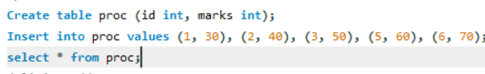

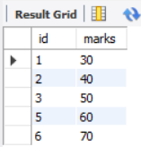

* Create a procedure to get the merit students (marks > 50).
* Create a procedure to get marks of a given id (using in).

